1).. Write a simple Timer that can periodically print a timeout message.

import java.util.Date;

import java.util.Timer;

import java.util.TimerTask;

public class MyTimerTask extends TimerTask { // MyTimerTask extended from TimerTask class

public void run() { //Overriding run method

System.out.println("Timer task started at:"+new Date()); // from Date package

completeTask();

System.out.println("Timer timedout at:"+new Date());

}

private void completeTask() { // Creating CompleteTask

try {

Thread.sleep(20000); //assuming it takes 20 secs to complete the task

} catch (InterruptedException e) { // to catch exception

e.printStackTrace();

}

}

public static void main(String args[]){

TimerTask timerTask = new MyTimerTask(); //running timer task as daemon thread

Timer timer = new Timer(true);

timer.scheduleAtFixedRate(timerTask, 0, 10*1000);

System.out.println("TimerTask started");

//cancel after sometime

try {

Thread.sleep(120000);

} catch (InterruptedException e) { // to catch exception

e.printStackTrace();

}

timer.cancel();

System.out.println("TimerTask cancelled");

try {

Thread.sleep(30000);

} catch (InterruptedException e) {

e.printStackTrace();

}

}

}

Output:-

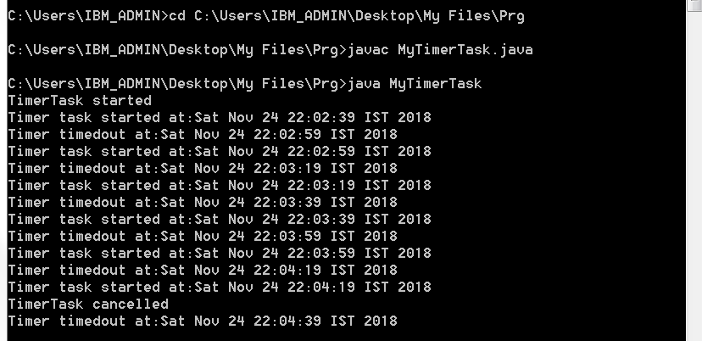

2) Write a program to build any collection containing duplicates. Create its copy with all duplicates

Removed

import java.util.Arrays;

public class DuplicateStr

{

static String removeDupsSorted(String str) // Method to remove duplicates in a sorted array

{

int res_ind = 1, ip_ind = 1;

char arr[] = str.toCharArray(); // Character array for removal of duplicate characters

while (ip_ind != arr.length) // In place removal of duplicate characters

{

if(arr[ip_ind] != arr[ip_ind-1])

{

arr[res_ind] = arr[ip_ind];

res_ind++;

}

ip_ind++;

}

str = new String(arr);

return str.substring(0,res_ind); //to return string value from given string

}

static String removeDups(String str) // Method removes duplicate characters from the string This function work in-place and fills null characters in the extra space left

{

char temp[] = str.toCharArray(); // Sort the character array

Arrays.sort(temp);

str = new String(temp);

return removeDupsSorted(str); // Remove duplicates from sorted

}

public static void main(String[] args)

{

String str = "NagarajuEnagundula";

System.out.println(removeDups(str)); // print string without duplicates

}

}

Output:-

